**Tadoba, Maharashtra**

The Tadoba Andhari Tiger Reserve is a wildlife sanctuary in Chandrapur district of Maharashtra state in India. It is Maharashtra's oldest and largest national park. Created in 1955, the reserve includes the Tadoba National Park and the Andhari Wildlife Sanctuary.

Legend holds that Taru was a village chief who was killed in a mythological encounter with a tiger. Taru was deified and a shrine dedicated to Taru now exists beneath a large tree on the banks of Tadoba Lake. The temple is frequented by [adivasis](https://en.wikipedia.org/wiki/Adivasi" \o "Adivasi), especially during a fair held annually in the Hindu month of [Pausha](https://en.wikipedia.org/wiki/Pausha) (December–January).

Reckoned among the largest and best Tiger Reserve in India, Tadoba National Park is the nation’s wildlife pride. It is situated in Chandarpur District in Maharashtra. Tadoba Tiger Reserve derives its name from the tribal God honored in this region Taru or Tadoba and the river that flows through the area Andhari.

1st image:

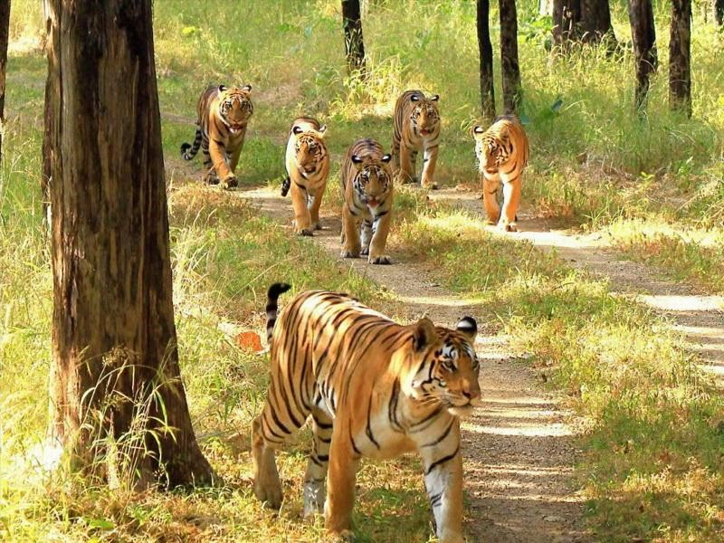

<https://tadoba-national-park-booking.com/wp-content/uploads/2018/02/Scarface_Madhuri-and-their-four-cubs.jpg>

2nd photo:

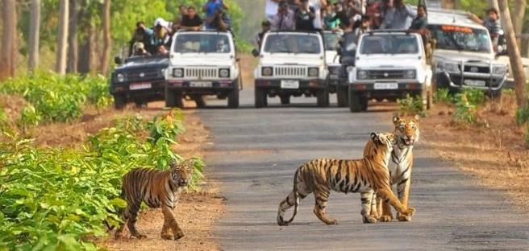

<https://www.tadobaandharinationalpark.com/images/banner1.jpg>